Junior English Literature Circles Book Titles and Descriptions
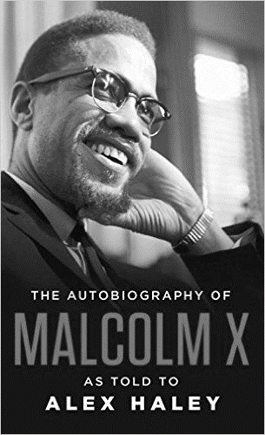 | The Autobiography of Malcolm X  By Malcolm X as told to Alex Haley  Published 1987; 460 pages  ONE OFTIME’S TEN MOST IMPORTANT NONFICTION BOOKS OF THE TWENTIETH CENTURY  Raised in Lansing, Michigan, Malcolm Little journeyed on a road to fame as astonishing as it was unpredictable. Drifting from childhood poverty to petty crime, Malcolm found himself in jail. It was there that he came into contact with the teachings of a little-known Black Muslim leader renamed Elijah Muhammad. The newly renamed Malcolm X devoted himself body and soul to the teachings of Elijah Muhammad and the world of Islam, becoming the Nation’s foremost spokesman. When his conscience forced him to break with Elijah Muhammad, Malcolm founded the Organization of Afro-American Unity to reach African Americans across the country with an inspiring message of pride, power, and self-determination.  The Autobiography of Malcolm X defines American culture and the African American struggle for social and economic equality that has now become a battle for survival. Malcolm’s fascinating perspective on the lies and limitations of the American Dream, and the inherent racism in a society that denies its nonwhite citizens the opportunity to dream, gives extraordinary insight into the most urgent issues of our own time.  The Autobiography of Malcolm X stands as the definitive statement of a movement and a man whose work was never completed but whose message is timeless. It is essential reading for anyone who wants to understand America.
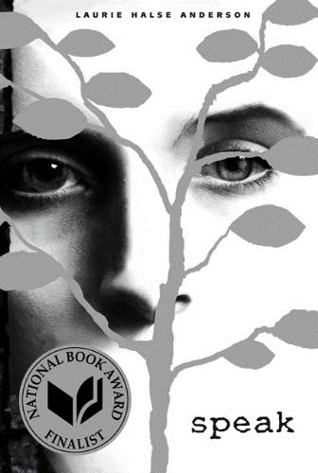 | Speak  By Laurie Halse Anderson  Published 1999; 224 pages  The first ten lies they tell you in high school.  "Speak up for yourself--we want to know what you have to say." From the first moment of her freshman year at Merryweather High, Melinda knows this is a big fat lie, part of the nonsense of high school. She is friendless, outcast, because she busted an end-of-summer party by calling the cops, so now nobody will talk to her, let alone listen to her. As time passes, she becomes increasingly isolated and practically stops talking altogether. Only her art class offers any solace, and it is through her work on an art project that she is finally able to face what really happened at that terrible party: she was raped by an upperclassman, a guy who still attends Merryweather and is still a threat to her. Her healing process has just begun when she has another violent encounter with him. But this time  Melinda fights back, refuses to be silent, and thereby achieves a measure of vindication. In Laurie Halse Anderson's powerful novel, an utterly believable heroine with a bitterly ironic voice delivers a blow to the hypocritical world of high school. She speaks for many a disenfranchised teenager while demonstrating the importance of speaking up for oneself.  Speak was a 1999 National Book Award Finalist for Young People's Literature.
Alas, Babylon
By Pat Frank
Published: 1959; 352 pages

"Alas, Babylon." Those fateful words heralded the end. When a nuclear holocaust ravages the United States, a thousand years of civilization are stripped away overnight, and tens of millions of people are killed instantly. But for one small town in Florida, miraculously spared, the struggle is just beginning, as men and women of all backgrounds join together to confront the darkness.
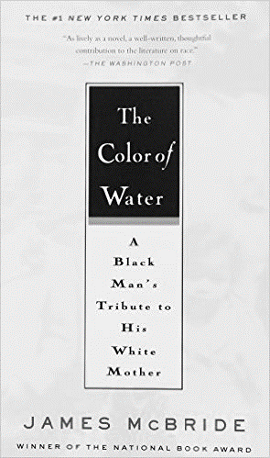 | The Color of Water  By Frank McBride  Published: 206; 295 pages  Who is Ruth McBride Jordan? A self-declared "light-skinned" woman evasive about her ethnicity, yet steadfast in her love for her twelve black children. James McBride, journalist, musician, and son, explores his mother's past, as well as his own upbringing and heritage, in a poignant and powerful debut, The Color Of Water: A Black Man's Tribute to His White Mother.  The son of a black minister and a woman who would not admit she was white, James McBride grew up in "orchestrated chaos" with his eleven siblings in the poor, all-black projects of Red Hook, Brooklyn. "Mommy," a fiercely protective woman with "dark eyes full of pep and fire," herded her brood to Manhattan's free cultural events, sent them off on buses to the best (and mainly Jewish) schools, demanded good grades, and commanded respect. As a young man, McBride saw his mother as a source of embarrassment, worry, and confusion—and reached thirty before he began to discover the truth about her early life and long-buried pain.  In The Color of Water, McBride retraces his mother's footsteps and, through her searing and spirited voice, recreates her remarkable story. The daughter of a failed itinerant Orthodox rabbi, she was born Rachel Shilsky (actually Ruchel Dwara Zylska) in Poland on April 1, 1921. Fleeing pogroms, her family emigrated to America and ultimately settled in Suffolk, Virginia, a small town where anti-Semitism and racial tensions ran high. With candor and immediacy, Ruth describes her parents' loveless marriage; her fragile, handicapped mother; her cruel, sexually-abusive father; and the rest of the family and life she abandoned.  At seventeen, after fleeing Virginia and settling in New York City, Ruth married a black minister and founded the all- black New Brown Memorial Baptist Church in her Red Hook living room. "God is the color of water," Ruth McBride taught her children, firmly convinced that life's blessings and life's values transcend race. Twice widowed, and continually confronting overwhelming adversity and racism, Ruth's determination, drive and discipline saw her dozen children through college—and most through graduate school. At age 65, she herself received a degree in social work from Temple University.  Interspersed throughout his mother's compelling narrative, McBride shares candid recollections of his own experiences as a mixed-race child of poverty, his flirtations with drugs and violence, and his eventual self- realization and professional success. The Color of Water touches readers of all colors as a vivid portrait of growing up, a haunting meditation on race and identity, and a lyrical valentine to a mother from her son.
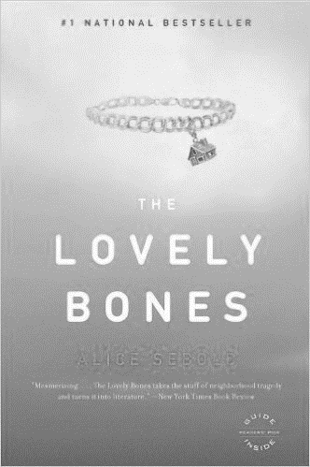 | The Lovely Bones  by Alice Sebold  Published: 2004; 352 pages  When we first meet 14-year-old Susie Salmon, she is already in heaven. This was before milk carton photos and public service announcements, she tells us; back in 1973, when Susie mysteriously disappeared, people still believed these things didn't happen. In the sweet, untroubled voice of a precocious teenage girl, Susie relates the awful events of her death and her own adjustment to the strange new place she finds herself. It looks a lot like her school playground, with the good kind of swing sets. With love, longing, and a growing understanding, Susie watches her family as they cope with their grief, her father embarks on a search for the killer, her sister undertakes a feat of amazing daring, her little brother builds a fort in her honor and begin the difficult process of healing. In the hands of a brilliant novelist, this story of seemingly unbearable tragedy is transformed into a suspenseful and touching story about family, memory, love, heaven, and living.
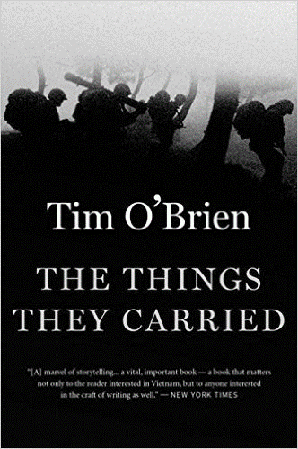 | The Things They Carried  By Tim O’Brien  Published: 1990; 246 pages  The Things They Carried is a novel by Tim O'Brien, about a platoon of American soldiers in the Vietnam War. His third book about the war, it is based upon his experiences as a soldier in the 23rd Infantry Division. O’Brien prefers to refrain from political debate and discourse regarding the Vietnam War, but has become jaded regarding the ignorance he perceives from the denizens of his home town toward the world. It is in part this ignorance that drove O’Brien to author The Things They Carried. It was initially published by Houghton Mifflin in 1990. Many of the characters are semi-autobiographical, sharing similarities with characters from his memoir If I Die in a Combat Zone, Box Me Up and Ship Me Home. The book works heavily with metafiction, employing a writing tactic called verisimilitude. The use of real names and inclusion of himself as the protagonist within the book creates a style that meshes and blurs the fiction and non-fiction. The Things They Carried is dedicated to the men of the Alpha Company with whom he fought during the war.

